How to Use USB Key
In order to improve the use of the XTOOL scanner.We update the hardware and also do encryption processing for the new developed program.
When using part of function,USB KEY must be worked together for old PS90.The following instructions to tell how to use.
1.USB KEY must be worked together with PS90 , can not be used on office laptop.
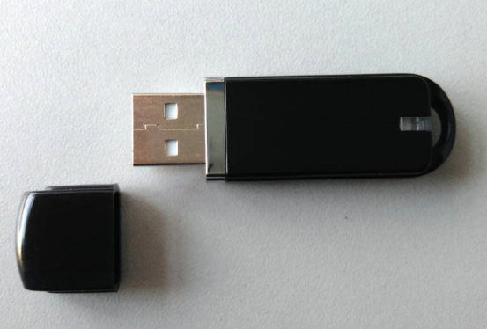
2.VCI box without version will be without USB KEY. Need to buy USB KEY.
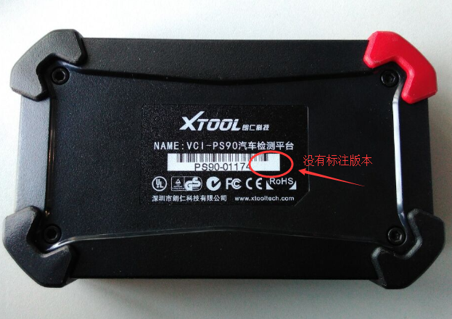
3.VCI box with version V1.6 or above is with USB KEY. No need to buy .
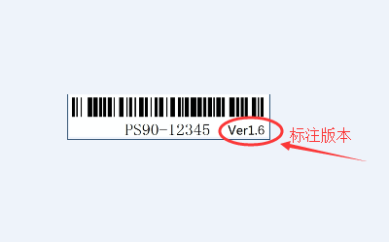
4.When using special function and require “insert USB KEY”.You need to insert or can not be used.

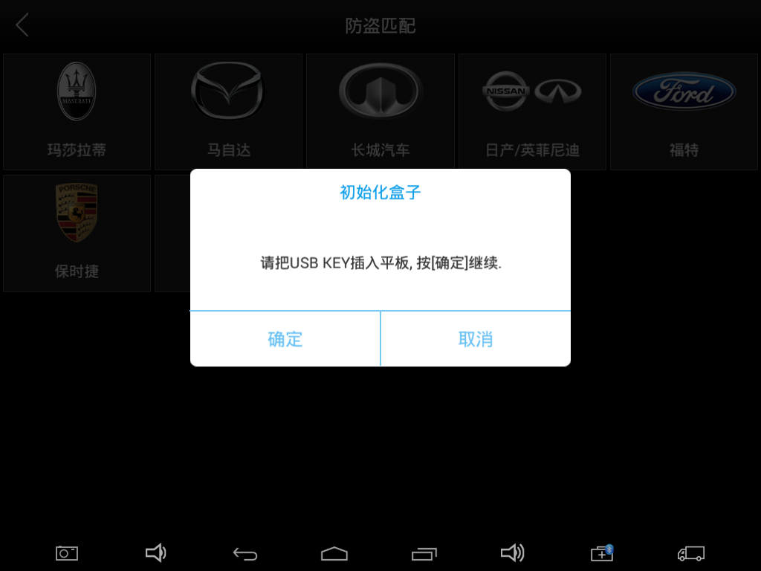

5.The USB port is on the right side of the scanner
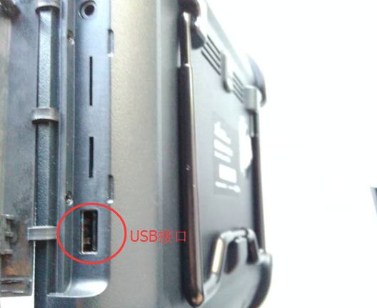
6.When insert USB KEY,the light on USB will be on
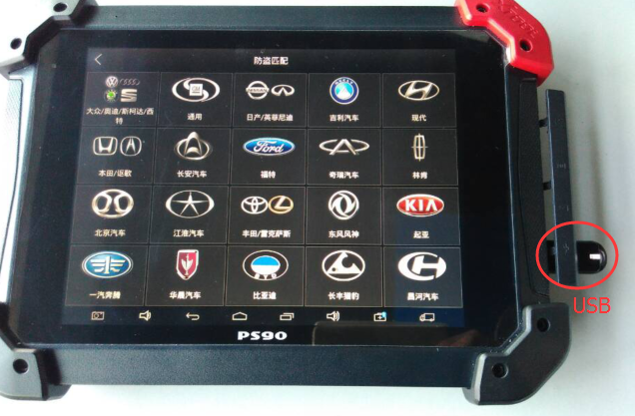

7.After inserting USB KEY and then press “OK”to continue the work till finishing all steps.
