X300PRO4 EU Version
- Product Name
Product Name: X300Pro4 EU Versione
- Product Description
X300 Pro4 is an all-purpose immobiliser programming device meticulously designed by OBDSTAR for locksmith in Europe area. The device inherits the automobile immobiliser programming technology from OBDSTAR with a lot of advantages of early start, wide model coverage, fast programming speed and special features.
The device keeping its software updating to latest car models. It’s cost-effective and high performance.
三. Product Advantages
1.Free upgrade for half a year
2.Within help data and tips (pics as below)
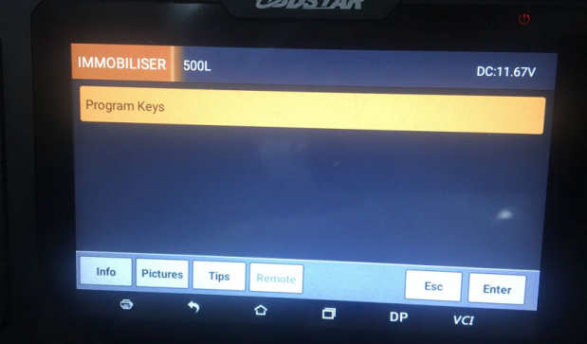
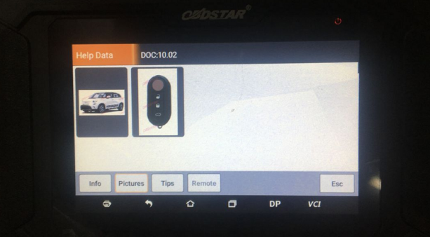
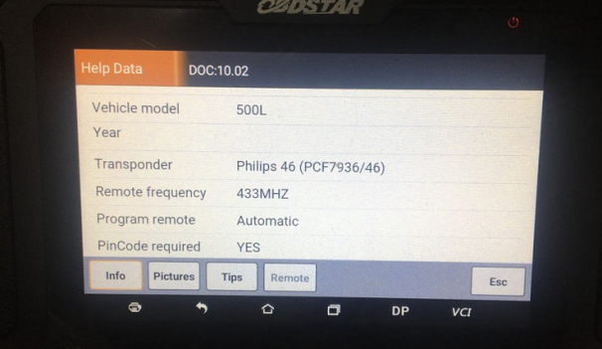
3. Extensive vehicle coverage and keeps updating
4. Support one-click remote assistance, one-click upgrade, one-click key programming, one-click clearing fault code, one-button screenshot
5. 5-inch Advanced Android touch screen tablet
四、Product Advanced Software
1.BMW CAS1 CAS2 CAS3 CAS3+ CAS3++ CAS4 CAS4+ FEM BDC key programming
2.BENZ disable/enable keys
3.MASERATI all series key programming up to 2020 (2018- car models need work with FCA cable)
4.PORSCHE 718,911, 997,BOXTER, CAYENNE,CAYMAN,MACAN,PANAMERA 49 make dealer keys and key programming, PORSCHE 911, 997, BOXTER, CAYMAN 46 decryption read pincode from original keys(work with P001 adapter)
5.LANDROVER JAGUAR key programming(free pincode), 2014-2018 car models make start keys( work with P001 adapter)
6.HYUNDAI/KIA all series key programming up to 2020, 46/47/8A/4A read pincode, engine replacement etc.
7.FORD/ LINCOLN all series key programming(free pincode) up to 2020, almost car models ALK in alarm active (no need to repeatedly disconnect/connect battery cables）
8.MAZDA all series key programming (free pincode) up to 2020
9.TOYOTA all series key programming up to 2018, 8A blade key all keys lost (work with Key SIM, no need to repeatedly disconnect/connect)
10.RENAULT/ DACIA read pincode by OBD, RENAULT new car models 4A read pincode by OBD (work with specific connector and P001 adapter)
11.NISSAN all series read pincode up to 2020 by OBD(including KICKS and some new car models)
12.SUBARU all series key programming, read IMMO data, make start keys, all keys lost (work with P001 adapter)
13. HONDA/ ACURA all series key programming (free pincode) up to 2020
14.PEUGEOT/ CITROEN, SD all series read pincode key programming(excluding a few car models)
15.VW/ AUDI/ SKODA/ SEAT/ ALFA ROMEO/ SMART/ LANCIA/ FIAT/ VOLVO/ IVECO/ ISUZU/ SSANG YONG/ MITSUBISH/ OPEL/ SUZUKI etc key programming
16. With OBDII diagnosis function
五. Packing List:
12Vcharger,
Main cable OBDⅡ-16

